Department of Computer Science and Engineering (Data Science)
CSDS-A | Batch A13 (CSE - Data Science, Section A)
AI-Enabled Digital Examination Seating Management System
(SeatWise)
S.No. | Student name | Roll / hall ticket no.
1 | A.SANJAY | 23K91A6702
2 | CH.NAVEEN | 23K91A6743
3 | D.KOTESH | 24K95A6705
4 | A.AKSHITH | [Roll number to be confirmed]
Under the guidance of: [GUIDE NAME], [DESIGNATION]
CONCLUSION, FUTURE SCOPE AND REFERENCES
This document concludes the project: what was achieved, the key findings, the known limitations, concrete future work, and the numbered list of references.

1 Summary of the Work
This project set out to replace the slow, error-prone and predictable preparation of examination seating with an intelligent, constraint-satisfying system. The result is SeatWise, a web application whose core is a two-stage OR-Tools CP-SAT engine: Stage A shares candidates between halls and gives each paper one colour class of the hall's seat grid, and Stage B lays out the seats of each hall with roll-number spacing, accessible seats and department mixing, using seeded random objectives so that the returned plan is a random member of the valid plans. An independent validator checks every plan before it is stored, and every plan records its seed and three SHA-256 fingerprints so that it can be reproduced and verified. Around the engine are a validated import, a seat map with live, explained editing, PDF and Excel outputs, QR seat slips, a public seat lookup, a tablet attendance register, analytics and an audit trail.

2 Objectives Achieved and Main Contributions
All six objectives of the project definition were achieved on the evidence available: seating is automated from uploaded data; capacity, subject and roll-number constraints are satisfied; spacing is enforced and seating is randomised; charts and hall-wise reports can be exported; seat lookup and attendance work in real time; and plan preparation takes seconds. Two added objectives, reproducibility and an honest evaluation, were also met. The qualifications are stated below. The main contributions are listed in the section on novelty and key contributions.

3 Key Findings
- Confining each paper to one colour class of a hall's seat grid makes same-paper neighbours impossible by construction, for any number of papers and for diagonal neighbours.
- On the benchmark, all 24 SeatWise plans met every hard rule, while none of the 72 baseline runs did. At 600 candidates roll-order seating leaves 1,253 same-paper pairs, round-robin 281 and a random shuffle 265; SeatWise leaves none.
- A 600-candidate sitting is seated in 2.4 s and a 2,000-candidate sitting in 4.8 s on a 12-thread desktop.
- Seeded randomisation within the valid set is as unpredictable as a random shuffle (correlation 0.065; 1.0% repeated pairs).
- The price of the construction is a front-row bias of 4.7 percentage points, and four-neighbour mode is slower (6.0 s).
- A deterministic budget, one worker per hall and SHA-256 sub-seeds make plans reproducible, which lets Verify prove that a plan was not hand-picked.
- 58 automated tests pass, and an end-to-end scenario of import, planning, export, lookup and attendance completes in 11.4 s.
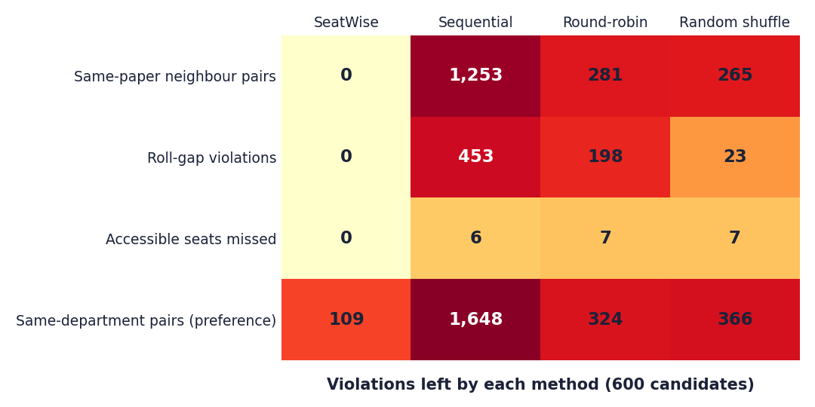
Fig. 1: Violations left by each method at 600 candidates (benchmark, mean of 3 seeds)
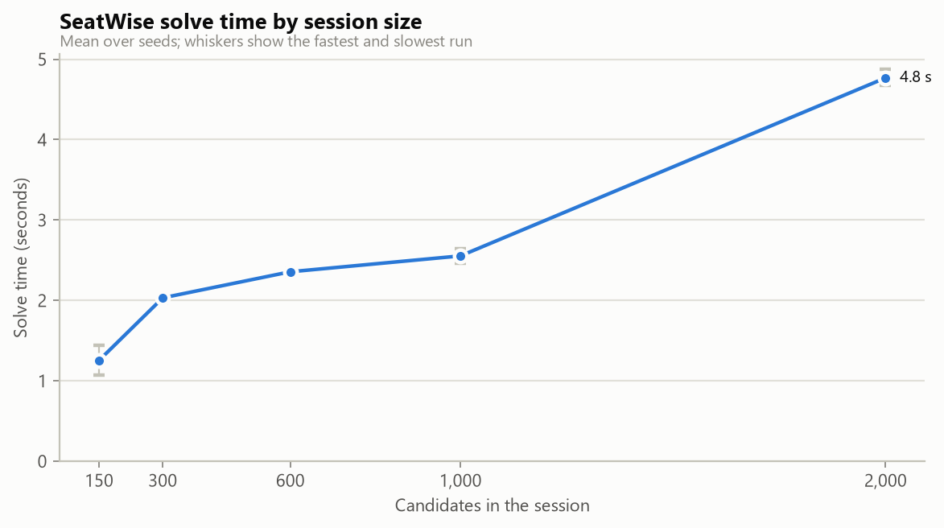
Fig. 2: Solve time by sitting size (benchmark)

4 Practical Applications
- Examination cells of colleges and universities preparing internal, semester and supplementary sittings.
- Schools and coaching institutes with multiple papers in one hall, where mixing papers is the usual anti-malpractice measure.
- Entrance and recruitment examinations that need fair, unpredictable and auditable seating, with a public seat lookup instead of notice boards.
- Any setting with grid seating and separation rules, such as lab slots or staggered sessions, by changing the rules rather than the engine.

5 Known Limitations
The evidence is from synthetic data, from one machine and from automated and scripted testing; no real examination cell or invigilator has used the system, so user acceptance is unknown. The front-row bias and the slower four-neighbour mode are known weaknesses of the design. The base paper reports no measurements, so the comparison with it is qualitative. There is no trained model, so accuracy-style metrics do not apply. These limitations are described in Chapters 1, 7 and 8 and shape the future work below.

6 Future Scope
The items below follow from the limitations and from the base paper's own future work.

7 Improvements
- Pilot and user study. Run the engine on a real, anonymised sitting, compare it with the cell's manual plan, and gather feedback from invigilators and the examination cell on the seat map, attendance screen and lookup page.
- Reduce the front-row bias. Rotate or randomise which colour classes include the front row, or add a fairness term to Stage A, and re-measure.
- Speed up four-neighbour mode. Tune the per-hall budget separately for each adjacency mode, or reduce the Stage B model by symmetry breaking.
- Better benchmarks. Repeat the benchmark on several machines, add larger and irregular halls, and publish the scenario generator as a reusable dataset.
- Front-end tests. Add component and end-to-end tests for the seat map and attendance screens.

8 Additional Features
- E-mail or SMS seat notifications and an installable mobile app, which the base paper also names as future work.
- Invigilator rostering that balances load and avoids conflicts of interest, beyond the current even assignment.
- Further objectives in the optimiser, such as seat visibility and distance between candidates, as in the genetic approach of Kashyap et al. [6].
- Support for combined seating of several examination types in one hall and for last-minute substitutions with minimal change to an existing plan.
- Attendance with face recognition, only after a privacy and consent review.

9 Scalability and Deployment
- Move from SQLite to a server database (PostgreSQL) and run the API behind HTTPS and a reverse proxy.
- Container images for repeatable installation and, optionally, cloud hosting for several institutions with separate workspaces.
- Run the engine as a background job with a queue so that very large sittings do not hold an HTTP request open.
- A security review: dependency audit, penetration test, and stricter password and session policies for a shared deployment.

10 Further Research
- Learn from real malpractice reports which neighbour patterns matter most, and weight the constraints accordingly.
- Study the trade-off between guaranteed separation and fairness of seat positions with exact or approximate fairness constraints.
- Compare CP-SAT with mixed-integer programming and local search on the same benchmark.
- Combine seating with timetabling so that the choice of papers per sitting is optimised for separability.

REFERENCES
[1] P. Yukth, I. S. Mahmood, K. H. Shashank, S. G. Thejus and M. S. Darshini, "Exam Seating Arrangement System," International Journal of Research Publication and Reviews (IJRPR), vol. 6, no. 12, pp. 2093-2105, Dec. 2025.
[2] "Automated examination seating arrangement and hall allocation system," International Journal of AI, Electrical, Civil and Mechanical Engineering, 2026.
[3] "An intelligent machine learning-based system for automated examination hall seating arrangement in universities," in Proc. 2026 Int. Conf. AI-Driven Solutions for Sustainable Smart Cities: Challenges and Opportunities (ADSSSC), 2026.
[4] S. O. Adetona and F. A. Akintoye, "Design and implementation of an examination seating arrangement application to curb examination malpractice," ABUAD Journal of Engineering Research and Development (AJERD), vol. 6, no. 2, pp. 143-156, Dec. 2023.
[5] "Automated seating arrangement for conducting examination," in Proc. 2025 Int. Conf. Multi-Agent Systems for Collaborative Intelligence (ICMSCI), 2025.
[6] Kashyap et al., "Exam seating allocation to prevent malpractice using genetic multi-optimization algorithm," Springer, 2021, doi: 10.1007/978-981-16-0419-5_11.
[7] K. Jitha and A. Fathima, "Web application based exam hall seating management system," in Proc. IEEE Int. Conf. Applied Artificial Intelligence and Computing (ICAAIC), 2022 (as described in [1]).
[8] M. Patel, "Smart seating system for universities," in Proc. IEEE Int. Conf. Computing, Communication and Automation, 2021 (as described in [1]).
[9] "Automated students examination seat allocation using linear congruential generator," International Journal of Computer Trends and Technology (IJCTT), 2021 (as described in [1]).
[10] "AI powered automated exam hall allocation and management system," International Journal of Science and Research (IJSART), 2025 (as described in [1]).
[11] D. J. A. Welsh and M. B. Powell, "An upper bound for the chromatic number of a graph and its application to timetabling problems," The Computer Journal, vol. 10, no. 1, pp. 85-86, 1967.
[12] R. Qu, E. K. Burke, B. McCollum, L. T. G. Merlot and S. Y. Lee, "A survey of search methodologies and automated system development for examination timetabling," Journal of Scheduling, vol. 12, no. 1, pp. 55-89, 2009.
[13] F. Rossi, P. van Beek and T. Walsh, Eds., Handbook of Constraint Programming. Amsterdam, The Netherlands: Elsevier, 2006.
[14] L. Perron and V. Furnon, "OR-Tools," Google. [Online]. Available: https://developers.google.com/optimization
[15] M. Jones, J. Bradley and N. Sakimura, "JSON Web Token (JWT)," RFC 7519, Internet Engineering Task Force, May 2015.
[16] N. Provos and D. Mazieres, "A future-adaptable password scheme," in Proc. USENIX Annual Technical Conference, 1999.
[17] S. Ramirez, "FastAPI documentation." [Online]. Available: https://fastapi.tiangolo.com
[18] M. Bayer, "SQLAlchemy," in The Architecture of Open Source Applications, vol. 2, A. Brown and G. Wilson, Eds., 2012.
[19] Meta Platforms, "React documentation." [Online]. Available: https://react.dev
Note: sources [2], [3] and [5] are listed from the batch literature survey; their abstracts could not be retrieved, so they are not described in the text. Sources [7]-[10] are described as the base paper [1] describes them.

